Optimization of Inventory Management for

Ronak Super Market.

Final Report Of BDM Capstone Project

Name :- Aniket Nagdare

Email Id :- [aniketnagdare2002@gmail.com](mailto:23f1002092@ds.study.iitm.ac.in)

**Table of Content**

1. Executive Summary and Title 3
2. Detailed Explanation of Analysis Process/Method 4
   1. : Data Analysis For Sales and Expenditure 4
   2. : Increase the overall profit of the business 6
   3. : Optimizing inventory 7
   4. : Fixed Cost Analysis 9
3. Results and Findings 9
   1. : Volume Analysis (Sales , Purchase) 9
   2. : Profit / loss Analysis 13
   3. : InventoryAnalysis 15
   4. : PL & INSIGHTS 16
4. Interpretation of Results and Recommendation 17
   1. : Recommendation 1: Increase the sales of high profit item 17
   2. : Recommendation 2: Increasing Sales of Milk 17
   3. : Recommendation 3: Restock inventory earlier than usual 18
   4. : Recommendation 4: Additional Steps 18
      1. : Effective Pricing Strategies 18
      2. : Enhance Store Display and Visual Merchandising 18
5. Conclusion 19
6. Important Links 19

# Executive Summary and Title :

Ronak Super Market, a medium-sized kirana shop established by Mr. Ramesh Choudhary in early 2015, is currently facing challenges related to profit and inventory management. These issues are indirectly affecting the store's net profit and sales. The objective of this capstone project is to understand the complexities of managing inventory and goods flow, enhance sales, and develop marketing strategies that boost net profit and sales for Ronak Super Market.

The primary goal of this project is to increase net profit by optimizing inventory management and determining the best times for purchasing goods. This involves a comprehensive analysis of sales data and fluctuations in purchase prices throughout the month. Identifying gaps and areas for improvement in the current strategy will be critical for this project.

The project will entail conducting an in-depth analysis of sales data to identify patterns and trends. Determining the best and worst-performing stock-keeping units (SKUs) will help in understanding the current sales dynamics. Using this sales data, effective marketing strategies will be formulated to improve net sales and profit.

Various Excel tools such as pivot tables, bar graphs, and line graphs will be utilized for data analysis and visualization. These tools will provide graphical representations of sales data, making it easier to identify trends, patterns, and key insights. By analyzing both outperforming and underperforming products using these tools, data-driven decisions and recommendations will be formulated to optimize revenue generation.

The project report will focus on recommendations to address identified problem areas, based on data-driven insights. Formulating marketing strategies and making informed business decisions will aim to enhance Ronak Super Market’s net profit and overall sales performance. By leveraging Excel for analysis and visualization, this project seeks to provide actionable recommendations for the store's success.

# Detailed Explanation of Analysis Process/Method :

#### : Data Analysis For Sales and Expenditure

* + - As mentioned above MS Excel is the main tool which will be used for the analysis.
    - Firstly sales data is collected in an unstructured format along with prices of each product from Ronak Super Market over the period of 31 days. This raw data is then entered into excel and basic data pre-processing tasks such as imputing, typing errors, sorting etc. are done.
    - The pre-processed sales data have a total of 21 columns where 10 columns represent each SKUs sales quantity along with the date (1 column) and 10 more represent each SKUs price on the given day.

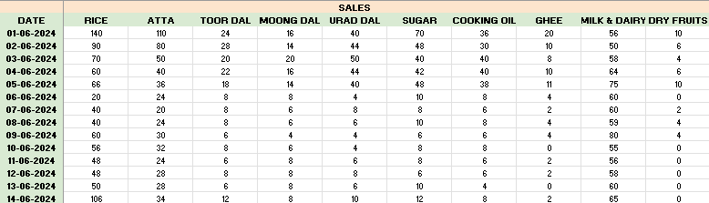

(Sales of Inventory in a Month)

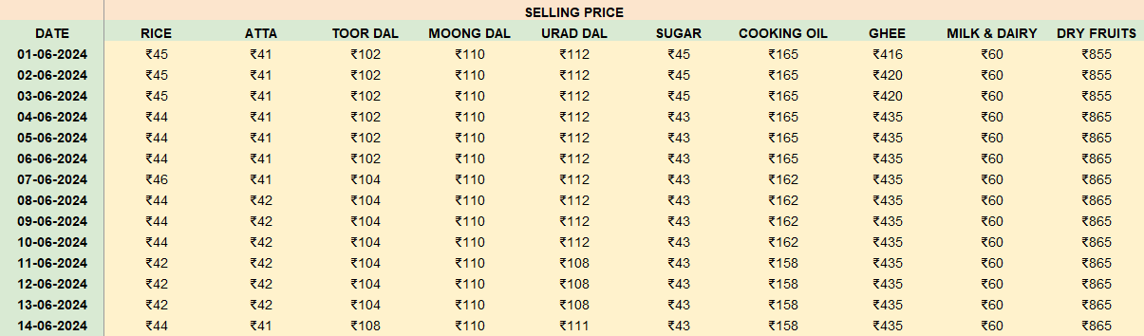

(Salling Price of Inventory in a Month)

* Using sales and selling price revenue for the day, average sales, selling price and total revenue can be calculated by formula:

𝑅𝑒𝑣𝑒𝑛𝑢𝑒 = 𝑆𝑒𝑙𝑙𝑖𝑛𝑔 𝑝𝑟𝑖𝑐𝑒 * 𝑆𝑎𝑙𝑒𝑠

𝑇𝑜𝑡𝑎𝑙 𝑅𝑒𝑣𝑒𝑛𝑢𝑒 = ∑ 𝑅

𝑖

Where Ri = Rev𝑒𝑛𝑢𝑒 made at ith day

* Similarly purchase data has been collected for every SKUs which consists of purchase quantity and purchase price , using which expenditure is calculated on each SKU.

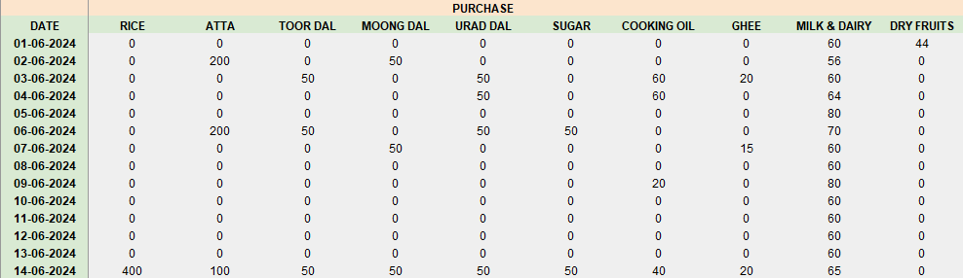

(Purchase of Inventory in a Month)

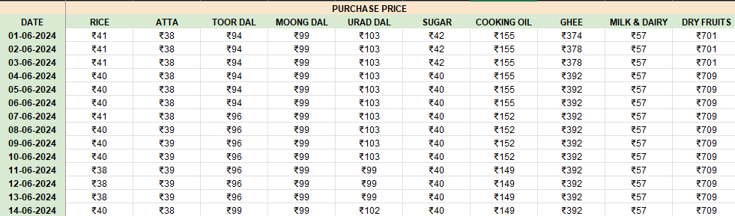

(Purchase Price of Inventory in a Month)

* Along with expenditure Total expenditure for the day, average expenditure per SKU as well as Total expenditure is calculated for 31 days using formulas :

𝐸𝑥𝑝𝑒𝑛𝑑𝑖𝑡𝑢𝑟𝑒 = 𝑃𝑢𝑟𝑐ℎ𝑎𝑠𝑒 𝑄𝑢𝑎𝑛𝑡𝑖𝑡𝑦 * 𝑃𝑢𝑟𝑐ℎ𝑎𝑠𝑒 𝑃𝑟𝑖𝑐𝑒

𝑇𝑜𝑡𝑎𝑙 𝐸𝑥𝑝𝑒𝑛𝑑𝑖𝑡𝑢𝑟𝑒 = ∑ 𝐸𝑖

𝑖 = 0

𝑡ℎ

where 𝐸

𝑖

= Expenditure at

𝑖 day

#### : Increase the overall profit of the business

* During my discussion with the business owner we discovered that due to high competition and entry of new shops and online grocery shops profits were declining, were not steady and it's becoming difficult for them to survive.
* Hence first step was to calculate profit / loss for each day, each SKU to determine the authenticity of the owner, for that I used sales and purchase data to calculate profit/loss, profit % for each SKU day using formula:

𝑃𝑟𝑜𝑓𝑖𝑡 = 𝑆𝑎𝑙𝑒𝑠 − 𝑃𝑢𝑟𝑐ℎ𝑎𝑠𝑒

𝑃𝑟𝑜𝑓𝑖𝑡𝑆𝐾𝑈 % = (𝑝𝑟𝑜𝑓𝑖𝑡 𝑆𝐾𝑈 / 𝑇. 𝑝𝑟𝑜𝑓𝑖𝑡) %

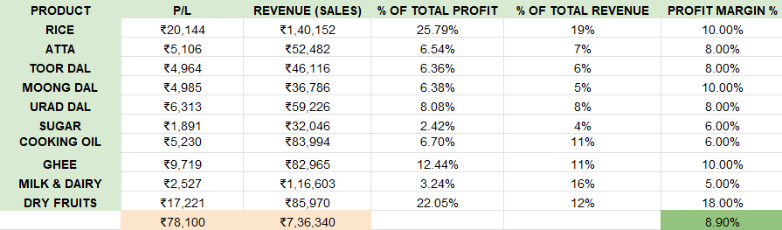

(Profit Margin’s)

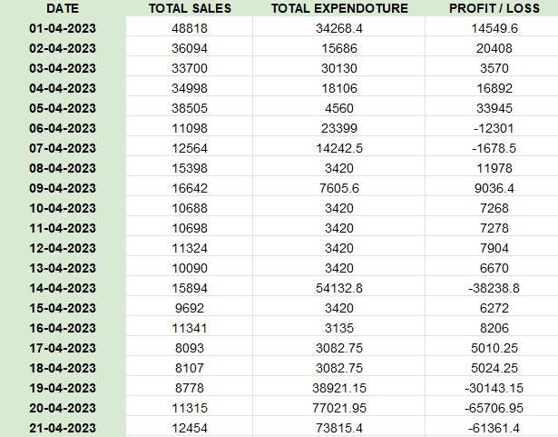

(Profit/Loss par Day)

* Considering the fact that there was some inventory for every SKU at the start and end of data collection purchase of each SKU was calculated using formula :

### 𝑃𝑢𝑟𝑐ℎ𝑎𝑠𝑒 = 𝑇. 𝑃𝑢𝑟𝑐ℎ𝑎𝑠𝑒 + 𝐼. 𝐼𝑛𝑣𝑒𝑛𝑡𝑜𝑟𝑦 − 𝐸. 𝐼𝑛𝑣𝑒𝑛𝑡𝑜𝑟𝑦

Where I.Inventory = Initial inventory , E.Inventory = End inventory , T.Purchase = Total purchase

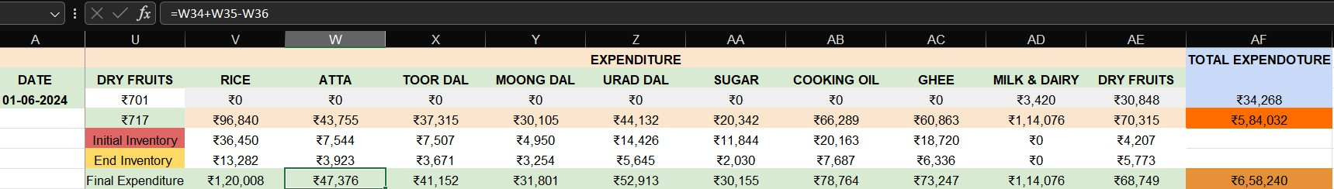

* Lastly cumulative profit was calculated for pareto chart

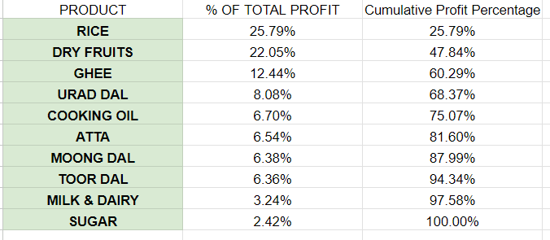

## : Optimizing inventory

* Upon discussion with the owner we got to know that inventory management was the main concern for the owner as according to owner stock was piled up at the end of the month and also profit were less hence buying new stock was getting difficult due to inflation
* Inventory data is collected for every SKU at the first day of data collection (i.e. 1/6/23) . Further Inventory data is calculated using sales , purchase and initial inventory using formula :

### 𝐼𝑛𝑣𝑒𝑛𝑡𝑜𝑟𝑦𝑖 = 𝐼𝑛𝑖𝑡𝑖𝑎𝑙 𝐼𝑛𝑣𝑒𝑛𝑡𝑜𝑟𝑦𝑖 − 𝑆𝑎𝑙𝑒𝑠𝑖 + 𝑃𝑢𝑟𝑐ℎ𝑎𝑠𝑒𝑖

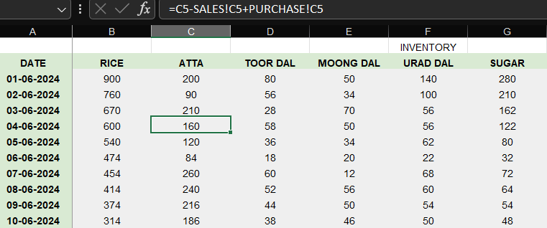

* Using inventory data average inventory , total inventory is calculated for every day as well as every SKU

𝑇𝑜𝑡𝑎𝑙 𝐼𝑛𝑣𝑒𝑛𝑡𝑜𝑟𝑦 = ∑ 𝐼𝑖

𝑖 = 0

𝑡ℎ

where 𝐼

𝑖

= Inventory at

𝑖 day

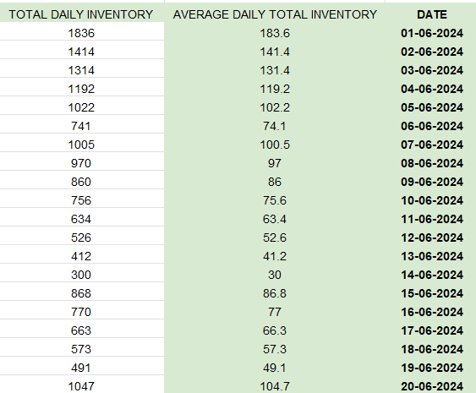

#### : Fixed Cost Analysis

* For fixed Cost analysis cost Transport , Rent , furniture , Electricity , Accessories , Loan were calculated for a period of 31 days (according to data) along with depreciation rate (approx as per area)
* According to data Total fixed cost was calculated

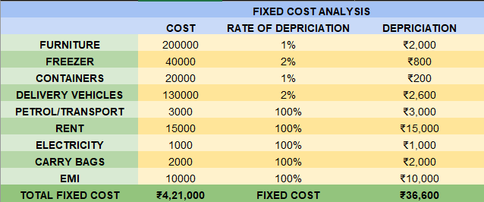

# Results and Findings :

#### : VOLUME ANALYSIS (SALES , PURCHASE)

The below graph is generated for the Revenue (Sales) generated for the month.

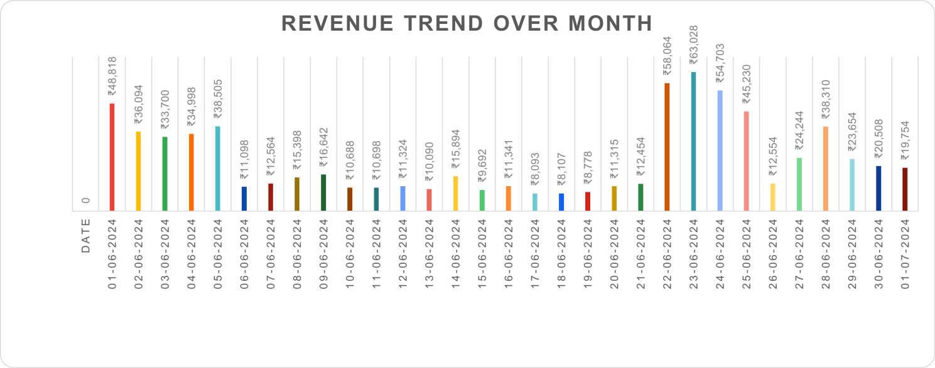

* The above analysis shows that start and end days for the month are the highest revenue generating days with early days of month end being the most important time (i.e. 22th - 28th) (referring this period to golden period)
* While it can also be seen that in middle of month the business is struggling to generate revenue
* The analysis above shows the average daily revenue stands at ₹23,753 with a standard deviation being ₹16557.77 which is quite high for such a low average indicating high revenue fluctuation
* Minimum revenue stand at : ₹8,093 (17/06/2024)
* Maximum revenue stand at : ₹63,028 (23/06/2024)
* Giving us a range of : ₹54,935 (using formula : 𝑅𝑎𝑛𝑔𝑒 = 𝑀𝑎𝑥 − 𝑀𝑖𝑛)

To analyze revenue generated by each SKU , the below graphs are generated 1) for the revenue generated by each SKU over the period of a month and 2) pareto chart in respect to the Total revenue generated over the period of a month

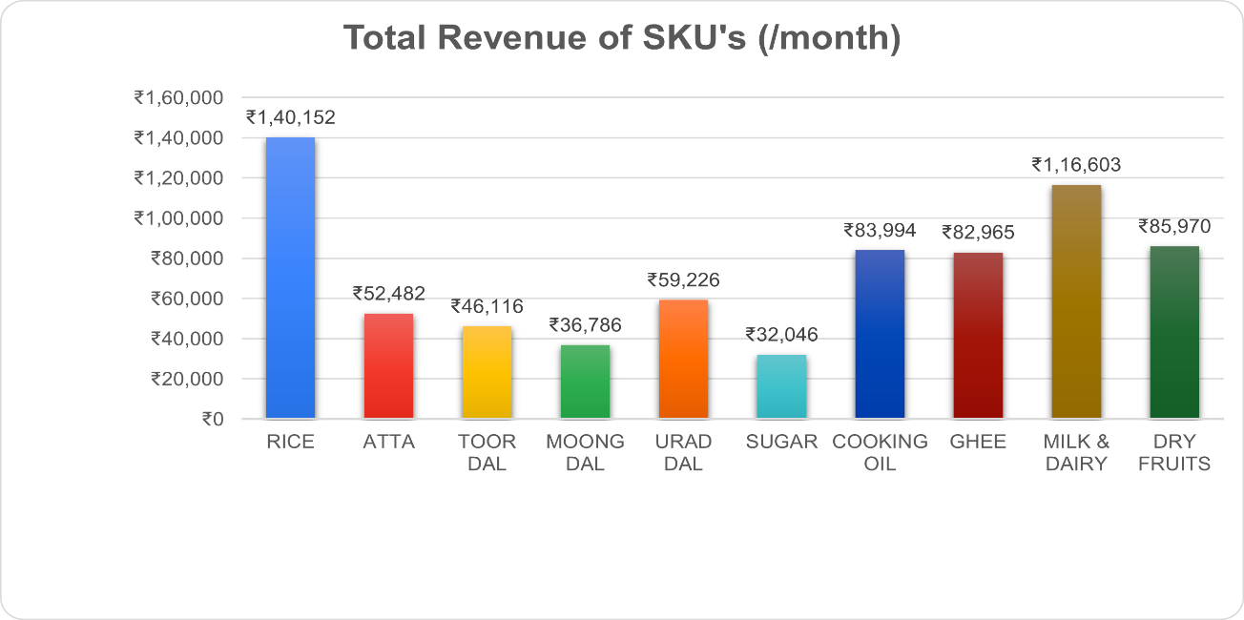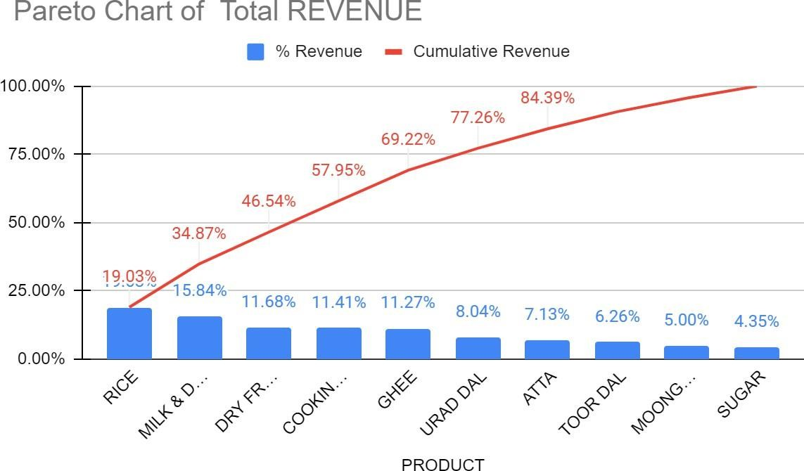

* Above analysis depicts that Rice , Milk & Dairy , Dry Fruits , Cooking Oil , Ghee and Urad Dal are the main revenue generating SKU for the shop which can be seen on the pareto chart can be seen as well as these 6 contributes approx 80% to the total revenue generated of the shop
* To analyze each SKU contribution along with pareto , the below graphs are generated to show the proportion of each SKU contribution to Total revenue generated as well as Total sales volume of the shop for a period of month

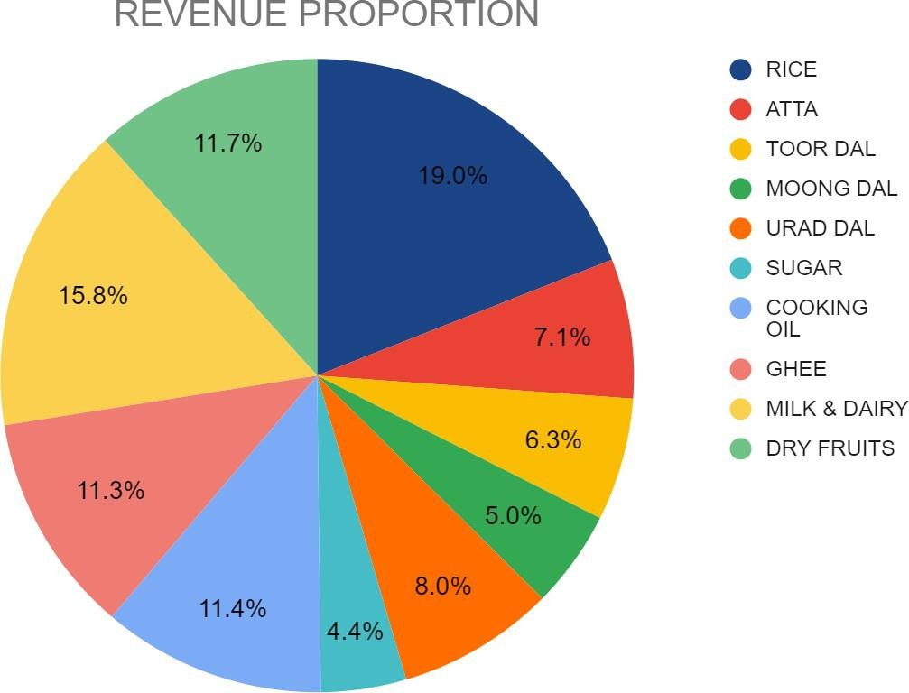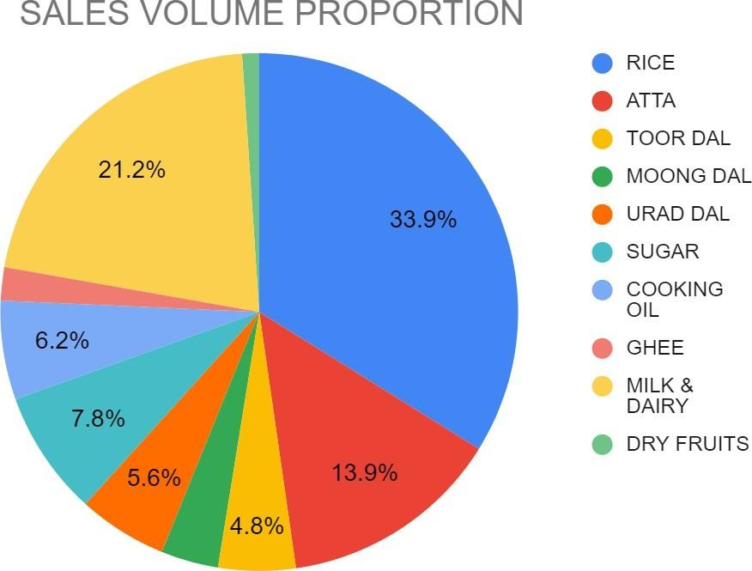

* From the above analysis it can be clearly deduced that Sales and revenue proportion for each SKU are directly related to each other meaning there is no high revenue generating product at low sales volume for the shop except
* Cooking oil and Ghee which has a contribution of 6.2% and 6% respectively to the sales volume proportion while having a contribution margin of 11.4% and 11.3% to the total revenue indicating high revenue generation at low volume in comparison to other SKU’s
* 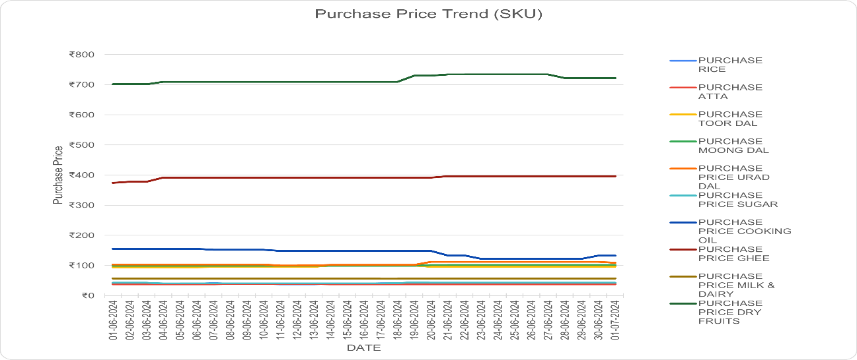It can also be seen that the major 6 SKUs from the pareto chart for revenue have a high sales volume proportion and revenue proportion making our pareto chart results validAfter Sales , to analyze the fluctuation or trend in purchase price , the below graph is plotted for the purchase price of each SKU over the period of month

The above analysis shows that there tends to be a slight increase in purchase price for most of the SKU’s (except Cooking oil) at the middle of the month to the end of the month which happens to coincide with the highest revenue generating period for the shop (i.e. 19th to 27th (golden period))

* + On the other hand Cooking oil purchase price tends to show a dip on the same period of time (golden time period) making it the best time to buy and generate profit from cooking oil
  + And Urad Dal purchase price tends to show a significant increase of ₹10 - ₹12 on the same period of time (golden time period) making it a early investing item (i.e. should be stocked earlier to make huge profit)

Based on above analysis below graph are plotted for Cooking oil and Urad Dal purchase price (Cost Price) and purchase to analyze the buying decision made by the owner

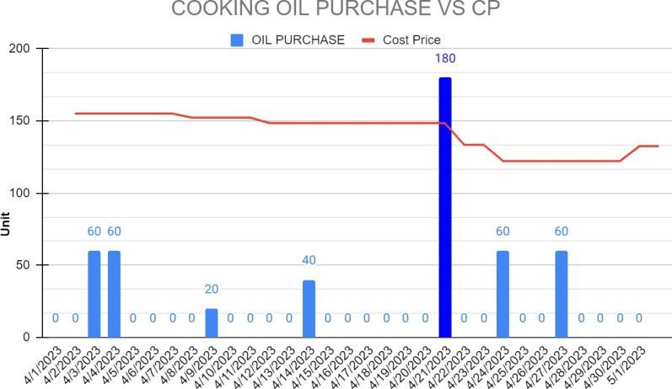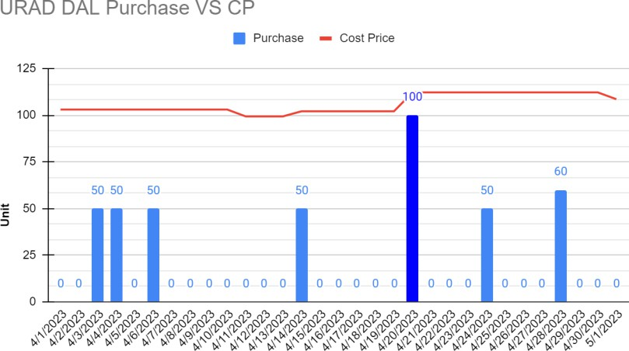

* + From above analysis it can be seen that shop owner made two wrong purchases , which were when prices were high , and the seller have earned at least extra 10-15 Rs/Kg, if it would have been brought 2-3 days later or earlier in respective case

#### : PROFIT / LOSS ANALYSIS

The below graph shows the comparison of avg purchase price to the average selling price for each item present in the shop which can be further used to calculate avg profit per item to analyze the areas / SKU’s which can be improved to increase net profit

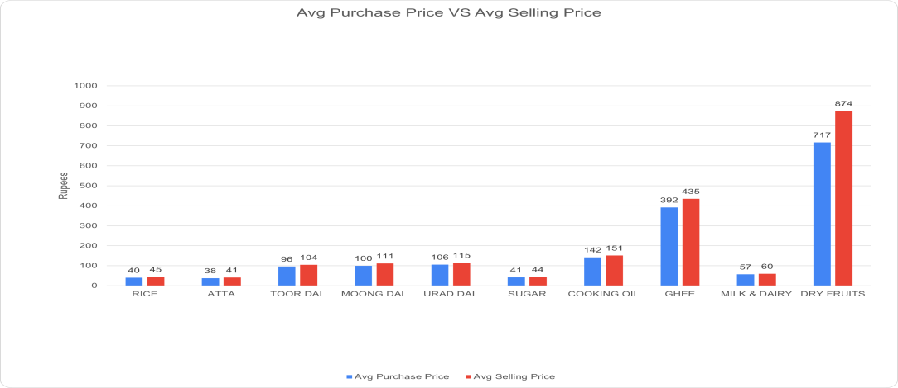

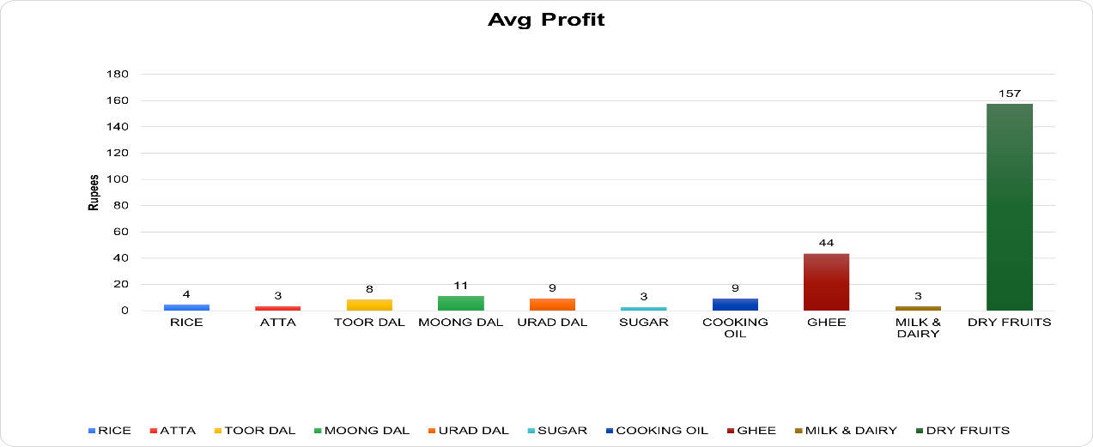

* From the above graph it can be seen that Dry fruits and Ghee are the items that holds maximum profit generating capacity while comparing this results to the revenue and revenue volume proportion pie chart it can be clearly seen that Dry Fruits and Ghee sales volume (1.1% and 2.1%) need to be improved for the shop to increase its net profit

Further to analyze , below graph is plotted for , each SKU contribution to the profit in comparison to the contribution in revenue

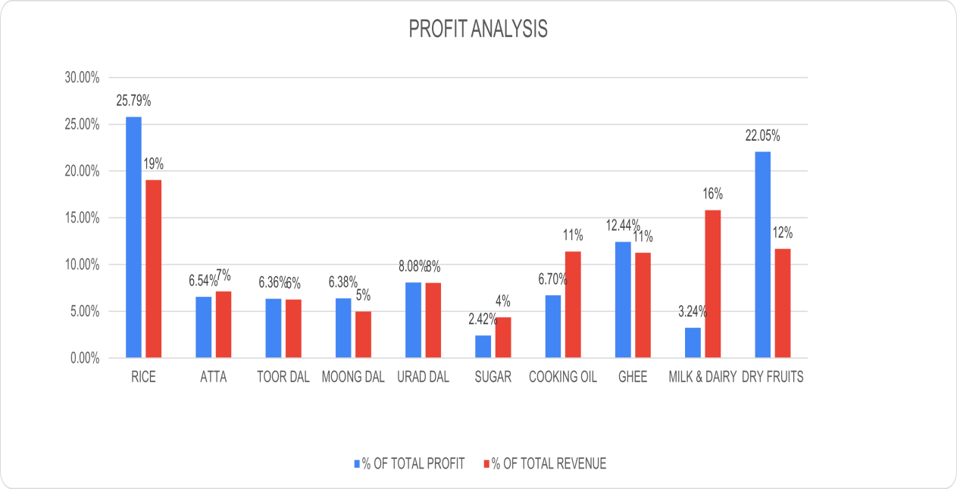

* The above analysis validated our previous analysis about Dry fruits
* It also concludes that although the shop is prosperous in Milk & Dairy , Cooking oil sales but their contribution to the overall profit remains significantly lower to that of others hence lower net profit which can be due to the fact of wrong purchase decision (shown above)

To validate our above finding , the below pareto chart for total profit is plotted

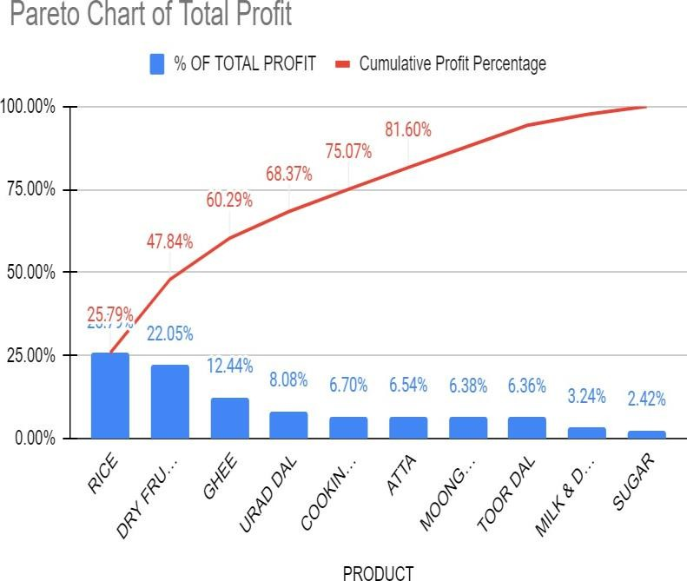

* From the above graph we can see that Rice , Dry Fruits , Ghee , Urad Dal , Cooking OIl and Atta to be the 6 SKU contributing to the 80% of shop total profit
* Secondly ,from the above graph, we do validate our above analysis about Milk & Dairy products (as they are not in 80%)

Furthermore , The below is generated to analyze the gross profit/loss over the period of month

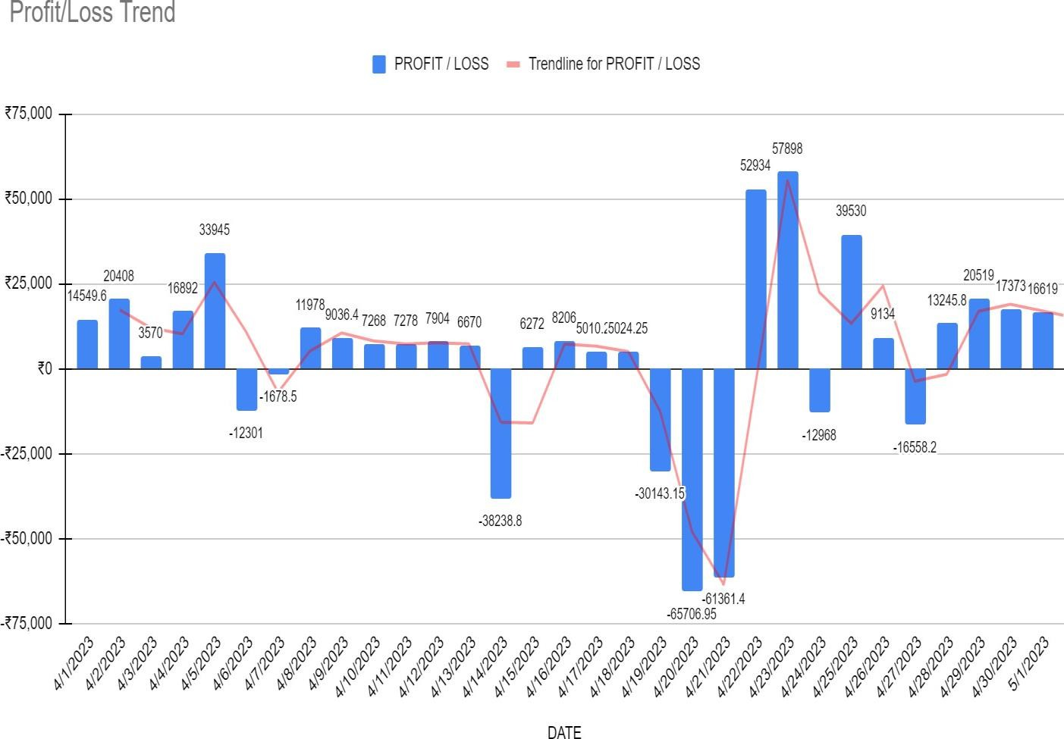

* From the above graph our analysis about the golden period for the shop (i.e. 22th - 28th) validates as well as it can be concluded that the wrong decision made by the owner in purchase of Cooking oil and Urad Dal (shown above) caused very high loss for the shop resulting in lower net profit

#### : INVENTORYANALYSIS

To start with inventory analysis , below graph represents the average stock in bags/carton for every item

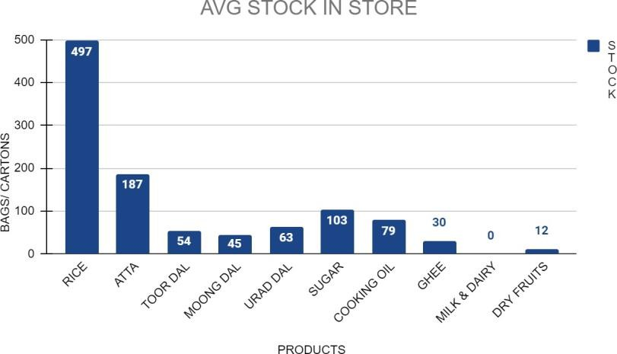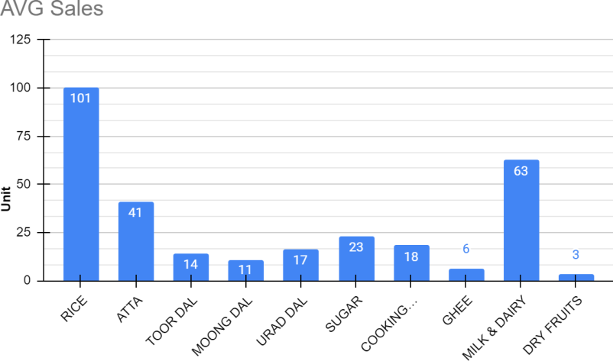

* Comparing the above avg stock graph with avg sales of the each item in exception to Milk & Dairy we can see that there are no abnormalities

As per owner claim of inefficient inventory management , the below graph is plotted to analyze inventory fluctuation over the period of month

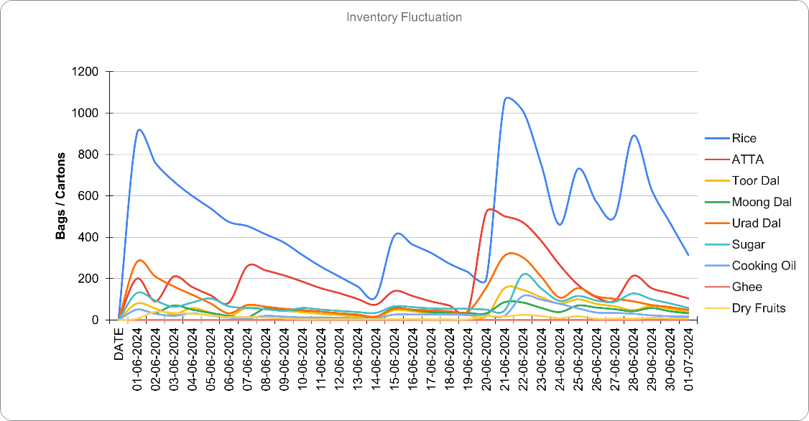

* From the above graph it can be clearly seen that although there are no abnormalities in avg stock as per sales but there are high fluctuation / variance in stock present in the inventory for every SKU around the golden period (i.e. 22th - 28th) when sales are high which clearly indicated poor planning and validates owner claim
* Secondly it can be observed that shop tend to refill it’s stock in relation to demand or when

stock is limited in inventory which can be referred to as a good practice but is backfiring in this particular case (given all months follow the same trend.)

#### : PL & INSIGHTS

Further to analyze the net profit firstly fixed cost is calculated using the data given by the owner



* The above table provides us with fixed cost analysis along with depreciation rate (approx given by the owner)
* Majority of the loan amount was used by the seller to purchase fixed assets. Also as it can be seen that the rate of depreciation for them is very low (1-2%), which is an indication of a good investment
* The amortized monthly cost of the fixed assets if only ₹56,000 , is very low compared to the returns he gets from them indicating good investment
* From the above table following things can also be calculated :
  + Total fixed cost : ₹421,000
  + Total Normalized Fixed cost : ₹36,600 , which can be used to calculate net profit using formula :

(𝑁𝑒𝑡 𝑝𝑟𝑜𝑓𝑖𝑡 = 𝐺𝑟𝑜𝑠𝑠 𝑃𝑟𝑜𝑓𝑖𝑡 − 𝑇𝑜𝑡𝑎𝑙 𝑁𝑜𝑟𝑚𝑎𝑙𝑖𝑠𝑒𝑑 𝐹𝑖𝑥𝑒𝑑 𝐶𝑜𝑠𝑡)

* + Net profit : ₹41,500

Further the below graph is plotted to analyze fixed cost proportion

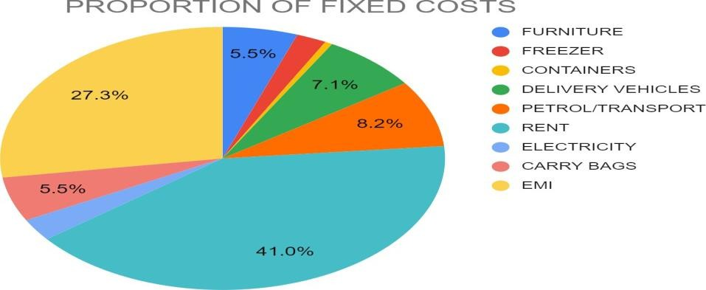

* From the above graph it can be seen that Electricity and Containers are the main contributors to the fixed cost but due to them being a necessity for shop there is not much reduction to do.

# Interpretation of Results and Recommendation :

#### Recommendation 1: Increase Sales of High-Profit Items

**Analysis**: Dry Fruits and Ghee have higher profit margins compared to other items.

#### Steps to Increase Sales:

1. **Seasonal Promotion**:
   * Host sales on dry fruits during winter when demand is high.

#### B2B Platforms and Business Partnerships:

* + Participate in B2B platforms or partner with businesses to sell Dry Fruits and Ghee at a lower rate than retail customers.
  + While reducing profit margin per unit, this can increase overall sales volume and net profits.

#### Bulk Sales and Discounts:

* + Offer larger quantities of dry fruits at discounted prices to encourage bulk purchases by customers and businesses.

#### Recommendation 2: Increasing Sales of Milk

**Strategies**:

1. **Morning-focused Milk Sales**:
   * Prioritize stocking milk for morning demand, as 98% of milk sales occur in the morning.
   * Encourage customers to purchase other goods with milk or offer free house delivery of milk to boost overall sales.

#### Introduce Delivery Charges:

* + After establishing a free delivery service, gradually introduce nominal delivery charges to cover costs and generate additional profits.

#### Recommendation 3: Restock Inventory Earlier Than Usual

**Issues**: Poor decisions in purchasing cooking oil and Urad Dal led to significant losses.

#### Recommendations:

1. **Time-based Restocking**:

* Restock inventory at fixed intervals, categorizing items into perishable and non- perishable goods.
* Identify items that can be purchased in advance to reduce the risk of last-minute decisions.

#### Timing Restock with High Sales Periods:

* Analyze data to identify high sales periods (e.g., 22nd to 28th of each month).
* Restock inventory slightly earlier than the high sales period to ensure sufficient availability.

#### Recommendation 4: Additional Steps

#### Effective Pricing Strategies:

* + - 1. **Bundle Pricing**:
         * Create bundled offers (e.g., dry fruits and ghee) at a discounted price to encourage multiple item purchases.

#### Promotional Pricing:

* + - * + Offer special promotions such as discounts, buy-one-get-one-free offers, or limited-time deals to attract customers and boost sales during specific periods.

#### Enhance Store Display and Visual Merchandising:

* + - 1. **Eye-Catching Displays**:
         * Arrange high-profit items like dry fruits and ghee in attractive displays near entrances or high-traffic areas.
         * Use creative signage or decorations to draw attention.

#### Sample Stations:

* + - * + Set up sample stations for products like dry fruits to allow customers to experience their quality and flavor, increasing purchase likelihood.

By implementing effective pricing strategies and enhancing store display and visual merchandising, the shop can create a more enticing and customer-friendly environment, leading to increased sales and profitability.

# Conclusion :

The analysis of Ronak Super Market's sales and expenditure data has provided valuable insights and actionable recommendations to enhance the shop's profitability and inventory management.

The analysis revealed that certain items, such as Dry Fruits and Ghee, have high-profit margins and represent significant opportunities for increasing sales. By implementing targeted marketing strategies, such as seasonal promotions and partnerships with other businesses, the shop can tap into the potential of these high-profit items. Additionally, offering bulk sales and discounts can incentivize customers to purchase larger quantities, further boosting sales volume and overall profitability.

The findings also highlighted the importance of optimizing inventory management. By restocking inventory earlier during high sales periods and improving planning and forecasting, the shop can ensure sufficient stock availability without excess inventory buildup or shortages. This will help to maintain customer satisfaction, reduce carrying costs, and improve overall operational efficiency.

Furthermore, the analysis emphasized the significance of making informed purchase decisions. The shop owner should closely monitor price fluctuations and market trends to avoid purchasing items at inflated prices, as observed with Cooking Oil and Urad Dal. By implementing a proactive approach to purchasing, the shop can minimize losses and increase profitability.

The analysis of fixed costs identified areas of expenditure that require attention, such as electricity and containers. The shop owner should continuously evaluate and optimize these costs to improve cost efficiency and maximize profit margins.

In addition, the recommendations to enhance store display and utilize effective pricing strategies can contribute to increased customer attraction and sales. Eye-catching displays, sample stations, and promotional pricing can create a positive shopping experience and encourage customers to make additional purchases, leading to higher revenue and profitability.

By implementing these recommendations, Ronak Super Market can improve its financial performance, increase profitability, and establish a stronger position in the market. It is important for the shop owner to continually monitor and evaluate the effectiveness of these strategies, making necessary adjustments to ensure long-term growth and sustainability.

# Important Links :

Spreadsheet :



[BDM Project Data](https://docs.google.com/spreadsheets/d/1MnAFIAKS2_a_eOt1tpQgD4i8Y5XeUq1G/edit?usp=drive_link&ouid=112512921338862437554&rtpof=true&sd=true)